Lab4 CIS43 Due: 6/28/2016

Name: Nikhil Vytla

***Exercise: Ex 5.12, 5.16, 5.17, 5.24***



OddProducts

**package** P512;

**public** **class** OddProducts {

**public** **static** **void** main(String[] args) {

**int** m = 1;

**for** (**int** n =1; n < 16; n += 2){

m = m*n;

}

System.*out*.printf("The product of the odd integers from 1 to 15 is: %d", m);

}

}

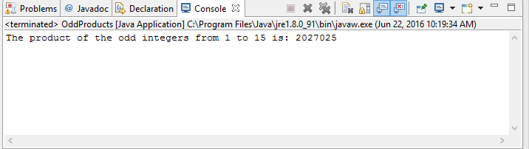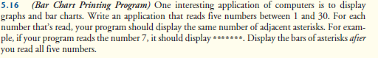

BarChart

**package** P516;

**import** java.util.Scanner;

**public** **class** BarChart {

**public** **static** **void** main(String[] args) {

Scanner input = **new** Scanner(System.*in*);

System.*out*.print("Enter an integer value between 1 and 30: ");

**int** number1 = input.nextInt();

System.*out*.print("Enter an integer value between 1 and 30: ");

**int** number2 = input.nextInt();

System.*out*.print("Enter an integer value between 1 and 30: ");

**int** number3 = input.nextInt();

System.*out*.print("Enter an integer value between 1 and 30: ");

**int** number4 = input.nextInt();

System.*out*.print("Enter an integer value between 1 and 30: ");

**int** number5 = input.nextInt();

**for** (**int** n = 0; n < number1; n++){

System.*out*.print("*");

}

System.*out*.println();

**for** (**int** n = 0; n < number2; n++){

System.*out*.print("*");

}

System.*out*.println();

**for** (**int** n = 0; n < number3; n++){

System.*out*.print("*");

}

System.*out*.println();

**for** (**int** n = 0; n < number4; n++){

System.*out*.print("*");

}

System.*out*.println();

**for** (**int** n = 0; n < number5; n++){

System.*out*.print("*");

}

System.*out*.println();

}

}

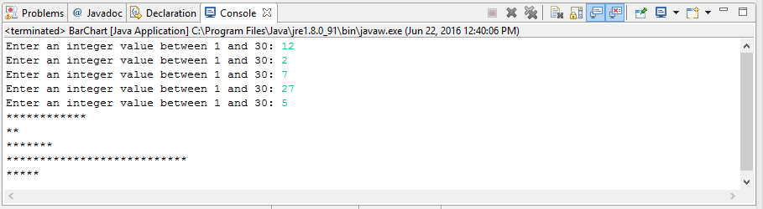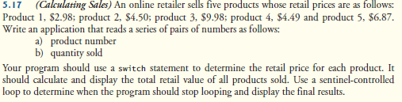

SalesCalc

**package** P517;

**import** java.util.Scanner;

**public** **class** SalesCalc {

**public** **static** **void** main(String[] args) {

Scanner input = **new** Scanner(System.*in*);

**double** price;

**double** total = 0;

**int** num = 0,quantity = 0;

System.*out*.print("You can stop this program at any time by inputting -1 for both the product number and the quantity.");

**while** (num != -1 && quantity != -1){

System.*out*.printf("%nPlease input your product number: ");

num = input.nextInt();

System.*out*.print("Please input your quantity sold: ");

quantity = input.nextInt();

**switch**(num){

**case** 1:

price = 2.98;

total += quantity * price;

**break**;

**case** 2:

price = 4.50;

total += quantity * price;

**break**;

**case** 3:

price = 9.98;

total += quantity * price;

**break**;

**case** 4:

price = 4.49;

total += quantity * price;

**break**;

**case** 5:

price = 6.87;

total += quantity * price;

**break**;

}

}

System.*out*.printf("%nThe total retail value of all products sold is: $%.2f!", total);

}

}

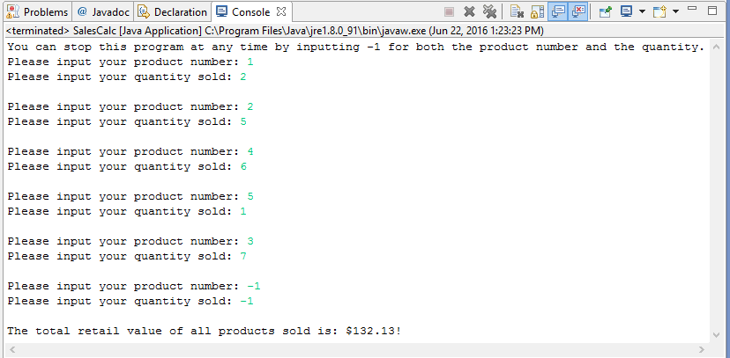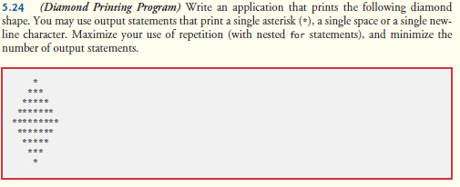

DiamondPrint

**package** P524;

**public** **class** DiamondPrint {

**public** **static** **void** main(String[] args) {

**for** (**int** a = 1; a < 10; a+=2){

**for** (**int** b = 0; b < 4 - a / 2; b++){

System.*out*.print(" ");

}

**for** (**int** b = 0; b < a; b++){

System.*out*.print("*");

}

System.*out*.println();

}

**for** (**int** a = 7; a > 0; a -= 2) {

**for** (**int** b = 0; b < 4 - a / 2; b++){

System.*out*.print(" ");

}

**for** (**int** b = 0; b < a; b++){

System.*out*.print("*");

}

System.*out*.println();

}

}

}

